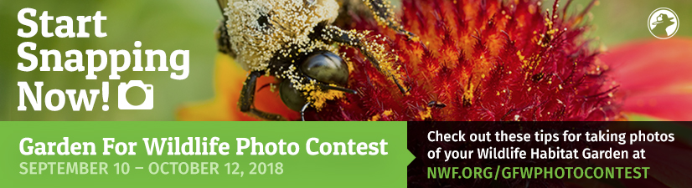

Start snapping now in preparation for the first annual National Wildlife Federation Garden for Wildlife™ Photo Contest, launching September 10, 2018!
We know you all garden for wildlife! And, you could probably make great use of $1,000! Our Partner, National Wildlife Federation, has invited our members to enter their first annual Garden for Wildlife™ Photo Contest, open for entries from September 10th – October 12th, 2018.

They are seeking photographs that illustrate the faces of Garden for Wildlife through striking, colorful images showcasing the impact of habitat gardens on wildlife and people – in urban, suburban, and rural settings, and on land, in the air, and in water.

Photographs may be submitted in one of the following four categories:
∙ People in the Wildlife Garden
∙ Close-Up Native Plants and Their Wildlife Visitors
∙ Wildlife Observed Where People Live, Work, Play, Learn, and Worship
∙ Wildlife Garden Habitat Features and Landscapes

Photo Contest Winners:
Grand Prize (one winner): $1,000 cash prize
Runner-Up (one winner): $500 cash prize
Category Winners: One winner from each category will receive a bird feeder and a copy of Wildlife Gardening: Tips for Four Seasons.
Young Habitat Photographer: Photos taken by youth (age 18 or younger) may be submitted by a parent or guardian on their behalf in any of the categories above to be eligible for this prize. One winner will receive a bird feeder and a copy of Wildlife Gardening: Tips for Four Seasons.
Visit www.nwf.org/gfwphotocontest for photo tips and more information. The entry forms and instructions will be available on that site on September 10th.
Submit multiple entries, identify yourself with NGC after your name, and show the world that NGC members take gardening for wildlife seriously!
SPECIAL NOTE: We know that many of our members, clubs, and states have held outstanding wildlife gardening projects. National Wildlife Federation has expressed interest in showcasing National Garden Clubs’ projects in their National Wildlife Magazine. What a great opportunity that would be! Please send pictures and write-ups about those special projects to this chairman and, with your participation, we will see if we can make this happen!
~ Becky Hassebroek, Wildlife Gardening Chairman, beckyhasse@aol.com, 907-456-3066
