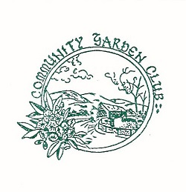
COMMUNITY GARDEN CLUB OF LIBERTY
Sullivan County, N.Y.
Federated Garden Clubs of New York State; District Ten
Organized and Federated in 1938
Mission: To encourage interest and love of gardening, aid in the
protection of nature, trees, plants, birds and scenic beauty,
inspire garden culture and floral decoration in and around our homes
and promote civic beautification in our community.
Meetings: Third Tuesday of the month except February at 1:00.P.M.
Business meetings and programs at members’ homes or other locations.
Guests and new members welcome.

Projects: Youth Scholarships to summer DEC camps awarded annually.
Horticulture Study
Field Trips to parks, botanical gardens, and flower shows; many open to the public
Meeting four times a year with fellow District Ten Garden Clubs.
Support World Gardening projects of FGCNYS
Garden Therapy at Adult Day Care Center, CRMC
Maintain Woodland Wildlings Gardens, Catskill Regional Medical Center

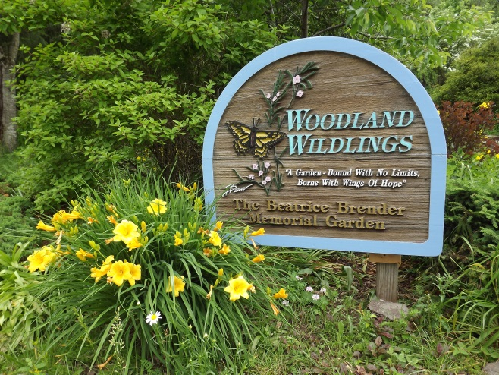
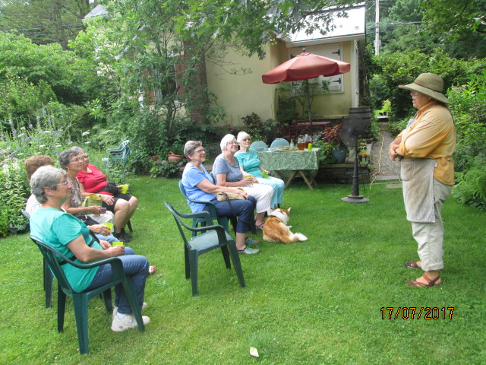
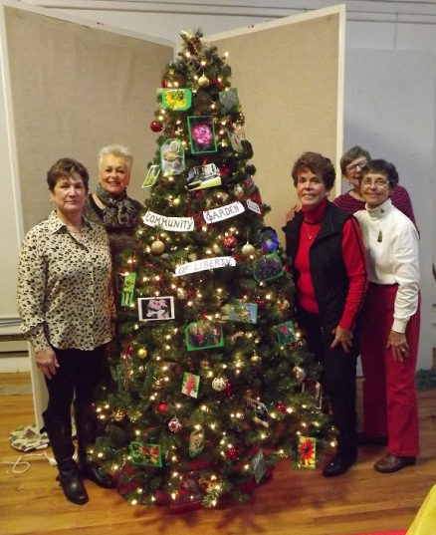

2017-2019 Officers: Co-Presidents: Judy Brennan 845-292-7832
Annie Hilton 845-482-5241
Vice-President: Lenore Weinstein
Secretary: Judy Bergstrom
Treasurer: Pat Allison
Corresponding Secretary: Jane Gordon

