“POP GOES the SEED”
Encourage and inspire our youth to use their imagination to create poetry. Each winner will receive a booklet with their published poem.
Eligibility: All students pre-school through 12.
Date of Submission: Club entries must be received no later than March 30, 2018
Contest Rules:
- All entries must be typed and titled.
- Include name, address, age, grade, type of poem and school of participant on back of entry.
- Sponsoring District and Club must also be identified.
- All entries become property of FGCNYS, Inc.
- Poems do not have to rhyme.
- Poems may be traditional verse, acrostics, blank verse, cinquains, diamond poems, limerick or Haiku.
- Pictures are encouraged.
Scale of Points
Title: 10% 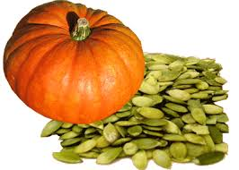
Content: 40%
Creativity: 30%
Style: 20%
Total: 100%
Submit by March 30, 2018 to:
Barb Millington, State Youth Chairman
546 County Route 76, Saratoga Springs, NY 12866

