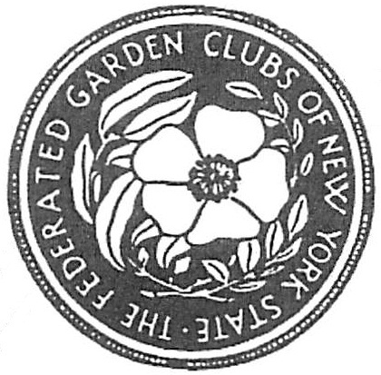

**FEDERATED GARDEN CLUBS OF NEW YORK STATE, INC**

**AWARDS APPLICATION 2017-2019**

**Award Name: Number (if applicable):**

**Submitted by:**

**(Enter name exactly as it should appear on any award received)**

**Name of Garden Club: Number in Garden Club:**

**Mailing Address of Garden Club:**

**District Awards Chairman: Phone: Email:**

**State Awards Chairman: Phone: Email:**

* **Application form is limited to three printed pages, front of pages only. (No report covers or binders allowed,**

**No plastic sheets allowed)**

* **Application form will not be returned. (Exceptions: publication (books), CD/DVD). Copy entry for your files.**
* **Deadlines for sending to District Chairman:**

**Publicity/Press Books January 25 to State Chairman**

**Award of Honor to State Chairman by January 15th**

**District Awards Chairman October 1st**

**State Awards Chairman November 1st**

**Flower Shows held after October 15 deadline is Dec 15th**

**Check other dates for youth awards**

**Please complete each topic, if applicable. Use numbering as below when completing form.**

**1. New Project: Yes_____ No______ Beginning date: Completion date:**

**2. Brief summary and objectives of project:**

**3. Involvement of club members, other organizations, etc.**

**4. Project expenses and means of funding:**

**5. Continuing involvement, follow-up, maintenance:**

**6. Attach or insert photos, digital photos, and/or landscape plan does not need to be professionally drawn).**