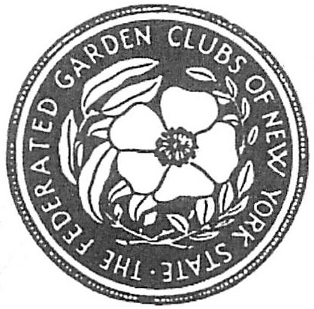
FEDERATED GARDEN CLUBS OF NEW YORK STATE, INC.
AWARDS APPLICATION 2021 -2023

Award Name: __________________________________________________________ Number (if applicable):_____________________

Submitted by: ___________________________________________________________________
(Enter name exactly as it should appear on any award received)
Name of Garden Club: ________________________________________________________
Number of Members in Club: ________________________________________________
Mailing Address of Garden Club: __________________________________________________________________________________
District # ___________
District Awards Chairman:_________________________________________
Address______________________________________________________________
________________________________________________________________________
Phone_____________________________Email___________________________________

State Awards Chairman: Cheryl A Kopyt Phone 315-839-6219 thekopyts25@gmail.com
8616 Canning Factory Rd. ,Waterville, NY 13480-1812

- Application form is limited to three printed pages, front only.
- (No report cover nor binders allowed. No plastic sheets allowed)
- Application form will not be returned. (Exceptions: publication (books), CD/DVD).
- Copy your entry for your files.
- Deadlines for sending to District Chairman: October 1, unless otherwise specified in Award Directions.
Publicity/Press Books January 25 to State Chairman
Award of Honor to State Chairman by January 15th
District Awards Chairman October 1st
State Awards Chairman November 1st
Flower Shows held after October 15, deadline is Dec 15th
Check other dates for Youth Awards

Please complete each topic, if applicable. Use numbering as below when completing application form.
1. New Project: Yes_____ No______ Beginning date: ___________ Completion date: __________
2. Write a Brief Summary and objectives of project
3. Involvement of club members, other organizations, etc.
4. Project expenses and means of funding
5. Continuing involvement, follow-up, maintenance:
6. Attach or insert photos, digital photos, and/or landscape plan (does not need to be professionally drawn).

