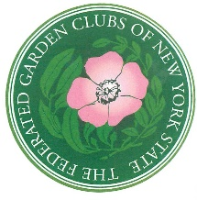
FEDERATED GARDEN CLUBS OF NEW YORK STATE
LIFE MEMBERSHIP APPLICATION

I would like to become a LIFE MEMBER of the FGCNYS to contribute to scholarship awards and educational projects. Please print the required information
Date of Application:
Name:
(As you would like it to appear in publication – only name and district appear)
Address:
City: State: Zip code:
Phone with area code: Email:
Garden Club Affiliate: District:
If this membership is a gift or surprise send to:
Name:
Address:
Telephone: Email:
Please include a $100.00 check made payable to: FGCNYS, Inc.
MAIL TO:
Federated Garden Clubs of NYS
Attn. Carol Anderson, Life Membership Chairman
292 Washington Avenue Extension, Suite 104
Albany, NY 12203-6385

QUESTIONS:
Carol Anderson, Life Membership Chairman
585-924-5687 or cha1937@frontiernet.net

